#### COLLEGE OF APPLIED SCIENCE VAZHAKKAD

**(Managed By Institute of Human Resources Development)**

**Affiliated to University of Calicut**



##### PROJECT REPORT

*Entitled on*

**BLOCKCHAIN VOTING SYSTEM**

**Submitted by:**

**AHAMMED HANI K**

**VAISHNAV P P**

**SABAREESH S**

**VIGNESH A C**

**Department of Computer Science**

**2021-2022**

#### COLLEGE OF APPLIED SCIENCE VAZHAKKAD

**(Managed By Institute of Human Resources Development)**

**Affiliated to University of Calicut**



**CERTIFICATE**

*This is to certify that the project entitled* ***“BLOCKCHAIN VOTING SYSTEM”*** *is a bona fide record of the project work done by* ***AHAMMED HANI K, VAISHNAV P P, SABAREESH S, VIGNESH A C*** *in partial fulfillment of requirement for the award of Degree of Bachelor of Computer Science under the University of Calicut during the academic year 2019-2022.*

###### PROJECTCO-ORDINATOR

**INTERNAL EXAMINAR EXTERNAL EXAMINAR**

# ACKNOWLEDGEMENT

I thank the almighty for giving me the courage and the perseverance in completing the project .This project itself is an acknowledgement for all those who have given as their heart- felt-co-operation in making it a grand success.

I am thankful to our principal **JAYAKOKILA P** for providing the necessary infrastructure and labs. We are greatly indebted to Head of computer science and my project guide **Ms**.**NAJEEDA** for valuable guidance at every stage of this project work.

I am also thankful to project coordinator **Mr.PANKAJ** for extending their sincere and guidance throughout this work, without their supervision and many hours of devoted guidance, simulating and constructive criticism, this would never come out in this form.

Last but not least, We would like to express my deep and earnest thanks giving to my parents for their moral support and heartfelt cooperation in doing the project. I would also like to thank my friends whose direct or indirect help has enabled me to complete this work successfully.

1. **INTRODUCTION 1**
2. **SYSTEM ANALYSIS** **3**

2.1 PROPOSED SYSTEM 4

* 1. USER REQUIREMENT SPECIFICATION 5
  2. SOFTWARE REQUIREMENT SPECIFICATION 6
  3. FEASIBILITY STUDY 7

2.5 SYSTEM SPECIFICATION 8

* + 1. HARDWARE SPECIFICATION 8
    2. SOFTWARE SPECIFICATION 8

1. SYSTEM DESIGN 9
   1. DATA DESIGN 10

3.2 DFD DESIGN NOTATIONS 11

* 1. DESIGN PROCESS 16
     1. DATABASE DESIGN 16
     2. NORMALIZATION 20
     3. INPUT DESIGN 21
     4. OUTPUT DESIGN 21

1. CODING 22
   1. FRONTEND 23
   2. BACKEND 25
2. TESTING AND IMPLEMENTATION 26
   1. TESTING 27
      1. TESTING METHODOLOGIES 27
      2. DIFFERENT TESTING 28
   2. SYSTEM IMPLEMENTATION 30
   3. SYSTEM MAINTENANCE 30
3. CONCLUSION 32

**7.** **FUTURE ENHANCEMENTS 34**

**8. BIBLIOGRAPHY 35**

**9. SCREENSHORT 36**

**10. SAMPLE SOURCE 41**

**INTRODUCTION**

## INTRODUCTION

With the problems raised on the trustworthy of voting system and fake voting’s, the necessity of efficient e-voting system has become inevitable among citizen. Though Electronic Voting Machine (EVM) provides an electronic voting mechanism, It is not sufficient and appropriate for an effective election. To overcome this limitation, the blockchain technology, which is used in bit coin or crypto currency makes it safer and provides a better democratic environment. Therefore, it is feasible and practical to choose the voting system using blockchain technology rather than electronic machine to implement the most secure democratic voting environment.

Blockchain is a shared, immutable ledger that facilitates the process of recording transactions and tracking assets in a business network. Virtually anything of value can be tracked and traded on a blockchain network, reducing risk and cutting costs for all involved. Blockchain is ideal for delivering that information because it provides immediate, shared and completely transparent information stored on an immutable ledger that can be accessed only by permissioned network members. A blockchain network can track the voting details. Members share a single view of the truth; you can see all details of a transaction end toend, giving you greater confidence, as well as new efficiencies and opportunities.

# SYSTEM ANALYSIS

## SYSTEM ANALYSIS

A system study is a process of studying a procedure to identify the objectives and purposes of a system as well as to analyse the existing system’s problems and drawbacks. The system analysis will create systems and procedures that will achieve these objectives as well as solutions to the problems in an efficient way. It is the process of gathering and interpreting facts, diagnosing problems and using the information to recommended improvements to the system. Training, experience and common sense are required for the collection of the information needed to do the analysis.

### 2.1PROPOSED SYSTEM

The system proposed a block chain based evoting system that uses “permissioned blockchain” to enable liquid democracy. In our proposal ,we will use a permissioned blockchain ,a variation of the consortium-basedchains ,which uses the proof-of-authority(POA) consensus algorithm. In proof-of authority-based networks ,transactions and blocks are validated by approved accounts, known as validators . This process is automated and does not require the validators to be constantly monitoring their computers. A permissioned blockchain which uses the POA consensus algorithm enables us to set restrictions on a set of selected known entities to validate and certify transactions on the blockchain and censor transactions arbitrarily, with their identity and reputation at stake. This otherwise needs to be done by miners on a public blockchain which uses the proof-of-work consensus algorithm. Rather than employing mining fees, like the public blockchains in operation require, using a permissioned blockchain, validators get payed for the service they provide by acting as validators in the system. Moreover, using a private network limits the possibility for an eavesdropper to monitor trafﬁc or read the incoming data. This is needed to fulﬁll voting rights so that voters can cast votes without leaking their identity or voting data.

## 2.2 USER REQUIREMENT SPECIFICATION

The system after careful analysis has been identified to be presented with the following module. The modules involved are:

* Admin
* Election coordinator
* Student

### ADMIN

In this module Admin is one who manages the entire working of the system. Following are the main functions that can be performed by the Admin:

1. Add & manage department
2. Add & manage course
3. Add & manage election coordinator
4. Add & manage student
5. Fix election date
6. View nominees
7. View complaints &reply
8. Publish Result
9. Add & view guideline

### ELECTION COORDINATOR

The election coordinator can login into their page and perform their functionality. They send the result to the admin and can view as well as verify the nominees.

1. View nominees and `verify
2. View Voting results
3. Send Result to Admin
4. Create blockchain & it’s node
5. Add & view report issue
6. Add & manage post

### STUDENT

The main functionality of the student is to cast the vote. They can send complaints and also send nominations.

1. Send Nomination
2. Send Complaints and view Reply
3. View Nominees
4. Voting using blockchain
5. View Result

### SOFTWARE REQUIREMENTSPECIFICATION

Software selection is an important work in a project development cycle. Software must be selected in accordance with the application and latest technology available. Main software used:

**Android Studio**:

It makes [mobile app development](https://www.brainvire.com/mobile-application-development/)easy because of its open-source platform. Also, the app developers can publish their apps immediately without any hassle. Lots of developers are associating with mobile app development for the Android platform considering its incredible growth.

**PyCharm:**

PyCharm provides smart code completion, code inspections, on-the- fly error highlighting and quick-fixes, along with automated code refactoring’s and rich navigation capabilities.

### 2.4 FEASIBILITY STUDY

Feasibility is defined as the practical extent to which a project can be performed successfully. To evaluate the feasibility, a feasibility study performed, which determine whether the solution considered to accomplish the requirements is practical and workable in the software.

Information such as resource availability, cost estimation for software development, benefits of the software to the organisation after it is developed and cost to be incurred on its maintenance are considered during the feasibility study. The objective of the feasibility study is to establish the reason for developing the software that is acceptable to users, adaptable to change and confirmable to established standards. The result should inform the decision of whether to go ahead with a more detailed analysis. The feasibility study is done in these phases:

* Technical feasibility
* Economical feasibility
* Operational feasibility

### TECHNICAL FEASIBILITY

It says that the system must be evaluated from the technical point of view. Having identified an outline system, the investigation must go on to suggest the type of equipment, required method for developing the system, method of running the system once it has been designed.

The current system developed is technically feasible thus it provides easy access to the user.

**ECNOMICAL FEASIBILITY**

Economic feasibility is assessed based on total expenditure and profit analysis. There are certain queries needed to be answered if the enterprise or company can develop the system, Is it profitable enough to stand above the expenses for its development of the system.

### OPERATIONAL FEASIBILITY

The purpose of the operational feasibility study is to determine whether the new system will be used if it is developed and implemented from users that will undermine the possible application benefits.

### 2.5 SYSTEM SPECIFICATION

The software requirements are description of features and functionalities of the target system. Requirements convey the expectations of users from the software product.

### HARDWARE SPECIFICATION

The selection of hardware is very important in the existence and proper working of any of the software. The size and capacity requirements are also important. The hardware must suit for all application developments.

1.Processor : Intel Pentium Core i3 and above 2.PrimaryMemory : 4GB RAM and above

3.Storage : 320 GB hard disk and above

4.Display : VGA Color Monitor

5.KeyBoard : Windows compatible

6.Mouse : Windows compatible

### 2.5.2 SOFTWARE SPECIFICATION

When the system requirement is found the we have to determine whether a particular software package is suit for those system requirements

* + - 1. OPERATINGSYSTEM : WINDOWS 10
      2. FRAMEWORK : FLASK
      3. SOFTWARESUSED : JetbrainsPycharm

### 2.5.2.1TECHNOLOGYUSED

1. FRONTEND : HTML,CSS,JAVASCRIPT
2. BACKEND : Mysql, python.

**SYSTEM DESIGN**

**SYSTEM DESIGN**

The most creative and challenging phase of the system life cycle is system design. The term design describes a final system and the process by which it is developed. It refers to the technical specification that will be applied in implementing the candidate system. It also include the construction of the program and the program testing. the key question involved here is “ how the problem should be solved”.

System design is a solution for the question of how to the approach to the creation of anewsystem.Thisimportantphaseiscomposedofseveralsteps.Itprovidestheunderstandingandproceduraldetailsnecessary for implementing the system recommended feasible study. Emphasis is on translating the performance requirements into design specifications. Design goes through logical and physical system; prepare input and output specification; make credit, security and control specification ; details the implementation plan ;prepare alogical design walk .Physical design maps out the physical system , plans the system implements, devices a test and implementation plan and specifies any new hardware and software.

The first most is to determine how the output is to be produced and in what format. Samples of output and input are presented. Second , input data and master files have to be designed to meet the requirements of the proposed output. The operational phases are handled through program construction and testing ,including a list Of Programs needed to meet the system ’s objective sand complete documentation. Finally, details related to justification of the system and estimate of the impact of the candidate system on the user and organization are documentation and evaluated by management as a step towards implementation. The final report prior to the implementation phases includes procedural flowcharts, record layouts and workable plan for implementing the candidate system.

**3.1** **Data Design (DFD)**

A data flow diagram (DFD) or a bubble chart is a graphical tool for structured analysis. DFD models a system by using external entities from which data flow to a process, which transforms the data and creates output data flows which go other process or external entities or files. Data in files may also flow to processes as inputs.

DFDs can be hierarchically organized, which help in partitioning and analyzing large systems. As a first step, one dataflow diagram can depict an entire system which gives the system overview. It is called context diagram of level0 DFD. The context diagram can be further expanded.

The successive expansion of a DFD from the context diagram to those giving more details is known as leveling of DFD. Thus a top down approach is used ,starting with an overview and then working out the details. The main merit of the DFD is that it can provide an overview of what data a system would process, what transformation of data are done, what files are used, and where the results flow.

##### 3.2 DFD Design Notation

In DFD, there are four main symbols

* Source or Destination of Data
* Process
* Flow of Data
* Temporary Repository of Data

### Figure 1: LEVEL 0 DFD

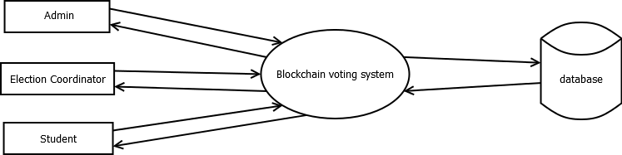

**Figure 2 : LEVEL 1.0 DFD (Admin)**

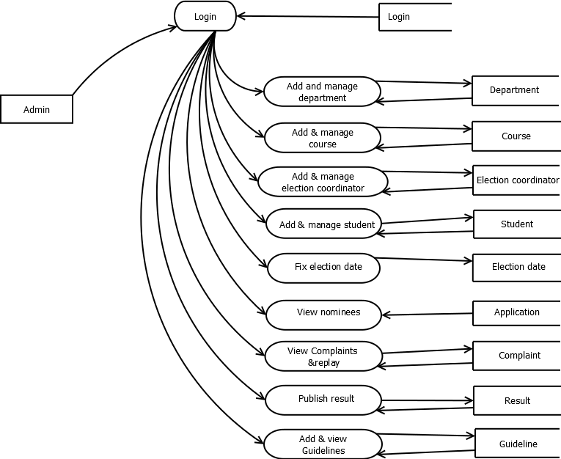

**Figure 3: LEVEL 1.2 DFD (Election coordinator)**

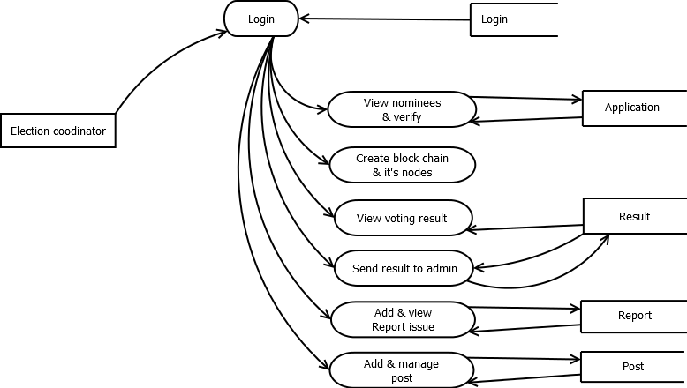

**Figure 4: LEVEL 1.3 DFD (Student)**

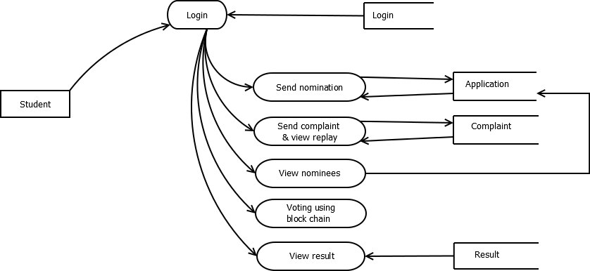

**3.3 Design Process**

A table is a data structure that organizes information into rows and columns. It can be used to both store and display data in a structured format. Databases often contain multiple tables, with each one designed for a specific purpose. Each table may include its own set of fields, based on what data the table needs to store. In database tables, each field is considered a column, while each entry (or record), is considered a row. A specific value can be accessed from the table by requesting data from an individual column and row. There are primary key fields for uniquely identifying a record in a table.

### 

### 3.3.1 Database Design

Database design is one of the most important aspects of Web programming. Successful implementation of any system with Data Storage will always need proper database design. To create a great database design, you will not only have to master the Database technology but will have to master the database design process and normalization.

**Table Structure**

### Login

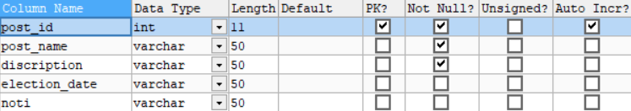

**Polling officer**

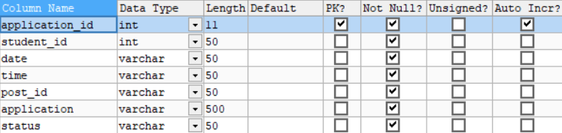

**Application**

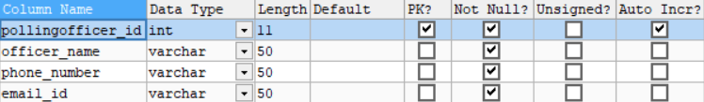

**Cipher**

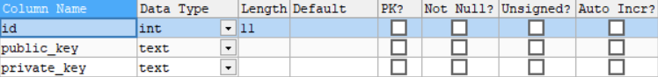

**Complaint**

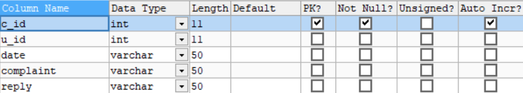

**Course**

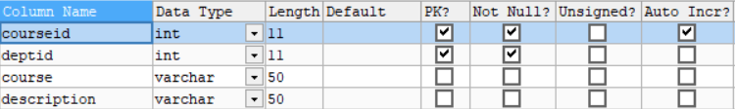

**Department**

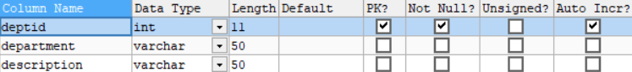

**Guideline**

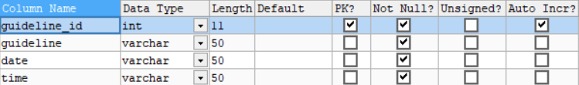

**Post**



**Report**

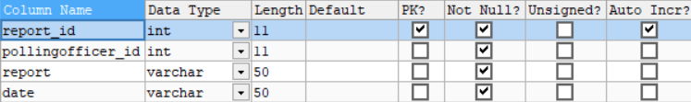

**Result**

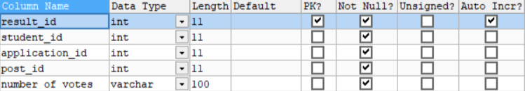

**Vote info**

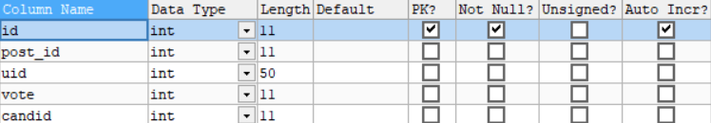

**Vote**

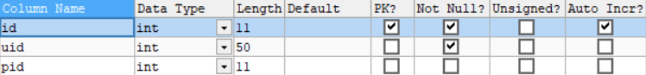

**Student**

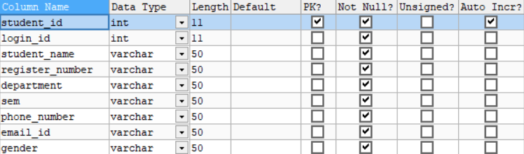

**Result publish**

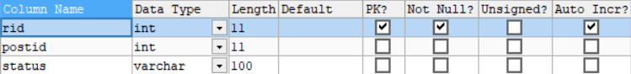

**3.3.2 Normalization**

Database Normalization is a technique of organizing the data in the database. Normalization is a systematic approach of decomposing tables to eliminate data redundancy(repetition) and undesirable characteristics like Insertion, Update and Deletion Anomalies. It is a multi-step process that puts data into tabular form, removing duplicated data from the relation tables. In our design the tables have been normalized up to third normalization form. Normalizations applied during database design are:

* First Normal Form(1NF)
* Second Normal Form (2NF)
* Third Normal Form (3NF)

### First Normal Form

If a relation contains composite or multi-valued attribute, it violates first normal form or a relation is in first normal form if it does not contain any composite or multi-valued attribute. A relation is in first normal form if every attribute in that relation is singled valued attribute. Our application satisfies 1 NF. The first normal form states that:

* Every column in the table must be unique.
* Separate tables must be created for each set of related data.
* Each table must be identified with a unique column or concatenated columns called the primary key.
* No rows may be duplicated.
* no row/column intersections contain a null value.

### Second Normal Form

A relation is said to be in 2NF if and only if it satisfies all 1NF conditions for the primary key and every non-primary key attributes of the relation is fully dependent on its primary key alone. If a non-key attribute is not dependent on the key, it should be removed from the relation and places as a separate relation. i.e., the fields of the table in 2NF are all related to primarykey.

### Third Normal Form

A relation is said to be in 3NF if and only if it is in 2NF and more over non-key attribute of the relation should not depend on other non-key attributes. The data in the system has to be stored and retrieved from database. Designing the database is a part of system design. Data elements and data structures to be stored have been identified at analysis stage. They are structured and put together to design the data storage and retrieval system.

### 

### 3.3.3 InputDesign

The input design is the process of converting the user-oriented inputs into the computer-based format. The goal of designing input data is make the automation as easy and free from errors as possible. For providing a good input design for the application, easy data input and selection features are adopted.

### 

### 3.3.4 OutputDesign

The output design has been done so that the results of processing should be communicated to the user. Effective output design will improve the clarity and performance of outputs. Output is the main reason for developing the system and the basis on which they will evaluate the usefulness of the application.

Output design phase of the system is concerned with the convergence of information to the end user-friendly manner. The output design should be efficient, intelligible so that system relationship with the end user is improved and they’re by enhancing the process of decision-making.

# 

# CODING

## CODING

The project is done with the help of Python and Android. Python is an interpreter, high-level, general-purpose programming language. Created by Guido van Rossum and first released in 1991, Python's design philosophy emphasizes code reliability with its notable use of significant whitespace. Its language constructs and object-oriented approach aim to help programmers write clear, logical code for small and large-scale projects. Python is dynamically typed and garbage collected.

It supports multiple programming paradigms, including procedural, object- oriented, and functional programming. Python is often described as a "batteries included" language due to its comprehensive standard library. Python was conceived in the late 1980s as a successor to the ABC language. Python 2.0, released in 2000, introduced features like list comprehensions and a garbage collection system capable of collecting reference cycles. Python 3.0, released in 2008, was a major revision of the language that is not completely backwards compatible, and much Python 2 code does not run unmodified on Python 3. Android is a mobile operating system developed by Google. It is based on a modified version of the Linux kernel and other open-source software and is designed primarily for touchscreen mobile devices such as smartphones and tablet devices. Also, Google has further developed Android TV for televisions, Android Auto for cars, and Wear OS for wrist watches, each with a specialized user interface. Variants of Android are also used on gaming consoles, cameras, PCs and many other electronic devices.

### 4.1 FRONT END

### PYTHON:

### Python is a multi-paradigm programming language. Object-oriented programming and structured programming are fully supported, and many of Its features support functional programming and aspect-oriented programming (including meta programming and meta objects (magic methods)). Many other paradigms are supported via extensions, including design by contract and logic programming. Python uses dynamic typing and a combination of reference counting and a cycle-detecting garbage collector for memory management. It also features dynamic name resolution (late binding), which binds method and variable names during program execution. Python’s design offers some support for functional programming in the Lisp tradition.

It has filter, map, and reduce functions; list comprehensions, dictionaries, sets, and generator expressions. The standard library has two modules (tier tools and functions) that implement functional tools borrowed from Haskell and Standard ML. Python is meant to be an easily readable language. Its formatting is visually uncluttered, and it often uses English keywords where other languages use punctuation. Unlike many other languages, it does not use curly brackets to delimit blocks, and semicolons after statements are optional. It has fewer syntactic exceptions and special cases than C or Pascal. Python's large standard library commonly cited as one of its greatest strengths provides tools suited to many tasks. For Internet facing applications, many standard formats and protocols such as MIME and HTTP is supported. It includes modules for creating graphical user interfaces, connecting to relational databases, generating pseudorandom numbers, arithmetic with arbitrary-precision decimals, manipulating regular expressions, and unit testing.

Most Python implementations (including C Python) include a read–eval–print loop (REPL), permitting them to function as a command line interpreter for which the user enters statements sequentially and receives results immediately. Other shells, including IDLE and I Python, add further abilities such as auto completion, session state retention and syntax highlighting.

As well as standard desktop integrated development environments, there are Web browser-based IDEs; Sage Math (intended for developing science and math related Python programs); Python anywhere, a browser-based IDE and hosting environment; and Canopy IDE, a commercial Python IDE emphasizing scientific computing.

### ANDROID:

Android is an open-source and Linux-based Operating System for mobile devices such as smartphones and tablet computers first developed by a Silicon Valley company by the name of Android Inc which Google bought in 2005. On November 5, 2007, the Open Handset Alliance, a consortium of technology companies including Google, device manufacturers such as HTC, Motorola and Samsung, wireless carriers such as Sprint and T-Mobile, and chipset makers such have Qualcomm and Texas Instruments, unveiled themselves, intending to develop "the first truly open and comprehensive platform for mobile devices" and the Android distribution was announced by them Android is also associated with a suite of proprietary software developed by Google, called Google Mobile Services (GMS) that very frequently comes pre-installed in devices, which usually includes the

Google Chrome web browser and Google Search and always includes core apps for services such as Gmail, as well as the application store and digital distribution platform Google Play, and associated development platform. Android includes middleware, libraries and APIs written in C and application software running on an application framework that includes Java- compatible libraries based on Apache Harmony. Android uses the Dalvik virtual machine with just-in-time compilation to r uncompiled Java code. The first commercial Android device launched in September2008.

### 4.2BACK END MySQL:

It is an open-source relational database system (RDBMS).Its name is a combination of "My", the name of co-founder Michael Widenius's daughter and "SQL", the abbreviation for Structured Query Language. A relational database organizes data into one or more data tables in which data types may be related to each other; these relations help structure the data. SQL is a language programmers use to create, modify and extract data from the relational database, as well as control user access to the database. In addition to relational databases and SQL, an RDBMS like MySQL works with an operating system to implement a relational database in a computer's storage system, manages users, allows for network access and facilitates testing database integrity and creation ofbackups.

MySQL is free and open-source software under the terms of the GNU General Public License, and is also available under a variety of proprietary licenses. MySQL was owned and sponsored by the Swedish company MySQL AB, which was bought by Sun Microsystems (now Oracle Corporation).

MySQL has stand-alone clients that allow users to interact directly with a MySQL database using SQL, but more often, MySQL is used with other programs to implement applications that need relational database capability. MySQL is a component of the LAMP web application software stack (and others). MySQL is written in C andC++.

## 

**TESTING AND IMPLEMENTATION**

## 5.1 Testing

System testing is actually a series of different tests whose primary purpose is to fully exercise the computer-based system. Although each test has a different purpose, all work to verify that all system elements have been properly integrated and perform allocated functions. Testing is the final verification and validation activity within the organization itself.

Testing is done to achieve the following goals: to test the quality of the product, to find and eliminate any residual errors from previous stages, to validate the software as a solution to the original problem, to demonstrate the presence of all specified functionality in the product, to estimate the operational reliability of the system. During testing the major activities are concentrated on the examination and modification of the source code.

## Testing methodology

### MANUAL TESTING

Manual testing is a software testing process in which test cases are executed manually without using any automated tool. All test cases executed by the tester manually according to the end user's perspective. It ensures whether the application is working, as mentioned in the requirement document or not. Test cases are planned and implemented to complete almost 100 percent of the software application. Test case reports are also generated manually. Manual Testing is one of the most fundamental testing processes as it can find both visible and hidden defects of the software. The difference between expected output and output, given by the software, is defined as a defect. The developer fixed the defects and handed it to the tester for retesting.

Manual testing is mandatory for every newly developed software before automated testing. This testing requires great efforts and time, but it gives the surety of bug-free software. Manual Testing requires knowledge of manual testing techniques but not of any automated testing tool. If the test engineer does manual testing, he/she can test the application as an end-user perspective and get more familiar with the product, which helps them to write the correct test cases of the application and give the quick feedback of the application.

## DIFFERENT TESTING

## UNITTESTING

It is the first level of testing. Each module is tested individually and focus is

given for finding errors limited to each individual module and correcting them. The different modules of the system are tested individually and corrected all errors. Each module is focused to work satisfactorily with regard to the expected output from the module. In computer programming, unit testing is a software testing method by which individual units of source code, sets of one or more computer program modules together with associated control data, usage procedures, and operating procedures, are tested to determine whether they are fit for use.

## INTEGRATION TESTING

Integration testing is a systematic testing for constructing the program structure while at the same time conducting tests to uncover errors associated with in the interfaces; all the modules are combined and tested as a whole. Integration testing tests whether the system works correctly with units that are integrated to do a particular function.

* + **Top-DownIntegration**

This method is an incremental approach to the construction of program structure. Modules are integrated by moving downward through the control hierarchy, beginning with the main program module. The module subordinates to the main program module are incorporated into the structure in either a depth first or breadth first manner.

* + **Bottom-UpIntegration**

This method begins the construction and testing with the modules at the lowest in the program structure. Since the modules are integrated from the bottom up, processing required for modules subordinate to a given level is always available and the need for stubs is eliminated.

## VALIDATION TESTING

For each input forms validation testing are done to ensure that only allowed values will be entered. Entering incorrect values does the validation testing and it is checked whether the errors are being considered. Incorrect values are to be discarded. The errors are rectified. Validation is determining if the system complies with the requirements and performs functions for which it is intended and meets the organization’s goals and user needs. Validation is done during testing like feature testing, integration testing, system testing, load testing, compatibility testing, stress testing ,etc.

### Front-End Validation

Everything is validated on the server to prevent someone creating an alternative client to access/manipulate database. Front end is also necessary as it improves efficiency and prevents the server being accessed with inappropriate data.

Front end validation is for data entry help and contextual messages. This ensures that the user has a hassle-free data entry experience and minimizes the round-trip required for validating correctness. Front end validation validates all input in a modern application, providing the user with quick feedback a possible issue

### Back-End Validation

Back-end validation is also an essential part. It has to ensure that the data coming in is needed valid. Additionally, depending on the architecture, generally re-use the middle-tier business logic among multiple components so need to ensure the rules that are applied are always consistent – regardless of what the front-end logic enforces.

## OUTPUT TESTING

After performing the validation testing, the next step is output testing of the proposed system, since no system could be useful if it does not produce the required output in the specific format. The output generated by the system under considerations is tested by asking the users about the format required by them

## System Implementation

Implementation is a process of ensuring that the information system is operational. It involves – Constructing a new system from scratch Constructing a new system from the existing one.

Implementation allows the users to take over its operation for use and evaluation. It involves training the users to handle the system and plan for a smooth conversion. System maintenance is an ongoing activity, which covers a wide variety of activities, including removing program and design errors, updating documentation and test data and updating user support. During the design phase, the products structure, its undergoing data structures, the general algorithms and the interfaces and control/data linkages needed to support communication among the various sub structures were established. Implementation process is simply a translation of the design abstraction into the physical realization, using the language of the target architecture.

There are three types of implementation:

* Implementation of a computer system to replace a manual system.
* Implementation of a new computer system to replace an existing one.
* Implementation of a modified application to replace an existing one computer.

## System Maintenance

The maintenance is an important activity in the life cycle of a software product. Maintenance Includes all the activities after the installation of software that is performed to keep the System operational. The maintenance phase of a software life cycle is the time period in Which a product performs useful work.

Maintenance is classified into four types:

* Corrective Maintenance
* Adaptive Maintenance
* Perfective Maintenance
* Preventive Maintenance

## CORRECTIVE MAINTENANCE

Corrective maintenance refers to changes made to repair defects in the design, coding, or Implementation of the system. Corrective maintenance is often needed for repairing Processing or performance failures or making changes because of previously uncorrected Problems or false assumptions. Most corrective maintenance problems surface soon after the Installation. When corrective maintenance problems surface, they are typically urgent and Need to be resolved to curtail possible interruptions in normal business activities.

### ADAPTIVE MAINTENANCE

Adaptive maintenance involves making changes to an information system to evolve its Functionality or to migrate it to different operating environment. Adaptive maintenance is Usually less urgent than corrective maintenance because of business and technical changes Typically occur some period of time.

### PERFECTIVE MAINTENANCE

Perfective maintenance involves making enhancements to improve processing performance, Interface usability, or to add desired, but not necessarily required, system features. Many System professionals feel that perfective maintenance is not really the maintenance but new Development.

### PREVENTIVE MAINTENANCE

Preventive maintenance is the only maintenance activity which is carried out without formal Maintenance request from the user. When a software company or maintenance agency Realizes that the methodologies used in a program have become obsolete, it may decide to Develop or modify parts of the program, which do not confirm to the current trends. Of these Types, more time and money is spending on perfective than on corrective and adaptive Maintenance together.

## CONCLUSION

## Conclusion

The system was implemented and tested with real data were to be error-free. Also, the system is working successfully. I tried to make the system maximum efficient and user friendly. The system is protected from any unauthorized access by giving the user name and password during the login process.

All the necessary validations are carried out in this project so that any kind of users can make use of this Web application. It is a responsive website so it adapts to any screen size. More designs and decorations should be added to the web pages to make them more attractive. All the disadvantages of the existing system have been overcome using the present system. The package was designed in such a way that future modification can be done easily. Here we are implementing an E-Voting system using blockchain technology to ensure the chance of vote for every student. In the current System, all tasks are to be done manually. His/her valuable time is wasting. The main objective of the project is to make the voting more secured and to ensure every students get their chance to cast the votes. This proposed system will exploit the benefits to all the students who could not attend the college on the day of election. The time and effort that we take today to cast our vote will be reduced in half. Once the proposed system is implemented the beneficiaries of this system will be the college unions and students.

## Future Enhancements

Blockchain voting system makes the election system in college more easy and tranquil. Along with voting information’s, it provides students and department information. It doesn’t require any technical knowledge – which means students from any department can cast their vote without any hesitant. When we cast the vote using EVM, there arises many confusions regarding if the vote is casted or not. This happens because of the number of buttons on a EVM and the time the signal takes to pass. The evolution of the blockchain voting system is inevitable. Like how we are currently using EVM’s, we can take this to next level – for the common elections. This will provide the next level of electronic voting system. This will open up a whole new level of experience for the voters. All the colleges can implement this voting system in their union election – so that it ensures every students votes as well as will reduce the total cost amount.

## BIBLIOGRAPHY

**Textbooks**

* Sommerville, I. (2016). Software engineering. Harlow: Pearson Education.
* Harwani B. M. (2013). Android programming unleashed. Indianapolis, IN: Sams.
* Darwin I. F. (2017). Android Cookbook: Problems and Solutions for AndroidDevelopers.

Beijing: OReilly Media.

* Elmasri R, & Navathe S. (2007). Fundamentals of database systems. Boston: Pearson/AddisonWesley.

**Web sites**

* [www.codeproject.com](http://www.codeproject.com/)
* [www.w3schools.com](http://www.w3schools.com/)
* www.tutorialspoint.com

**SCREENSHOTS**

**Android (Loginpage)**

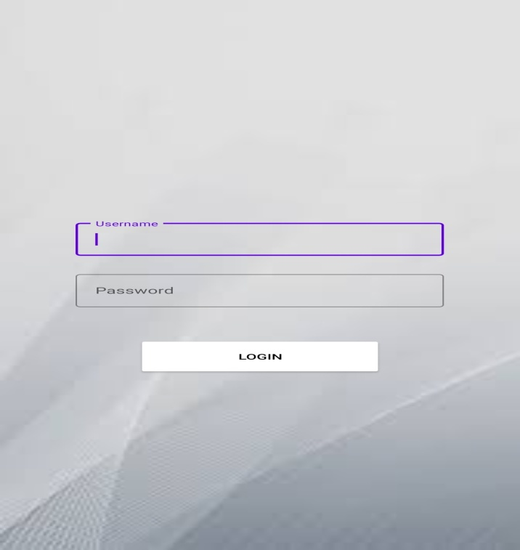

**MENU**

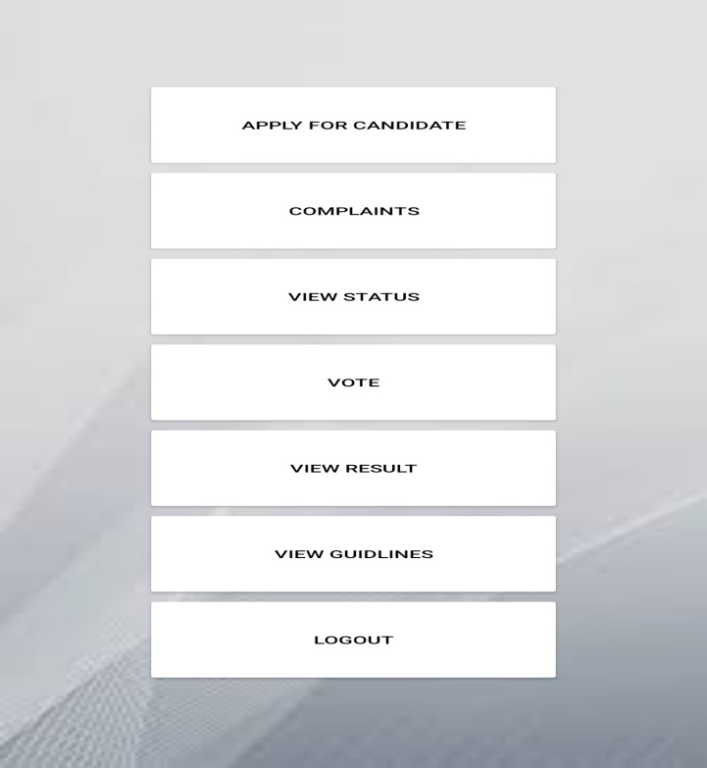

### WEB PART LOGINPAGE

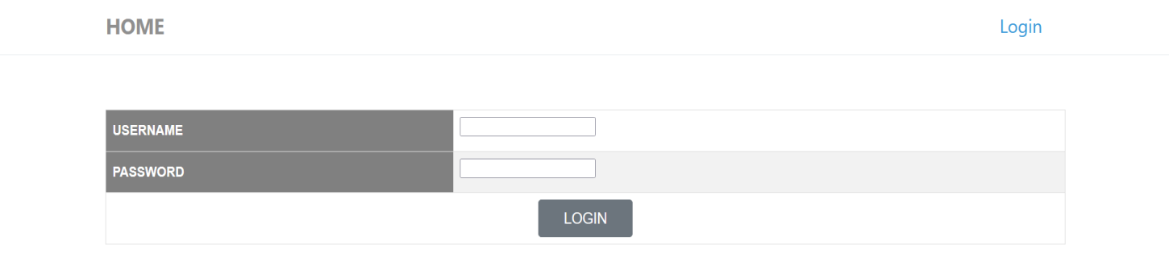

**ADD STUDENT**

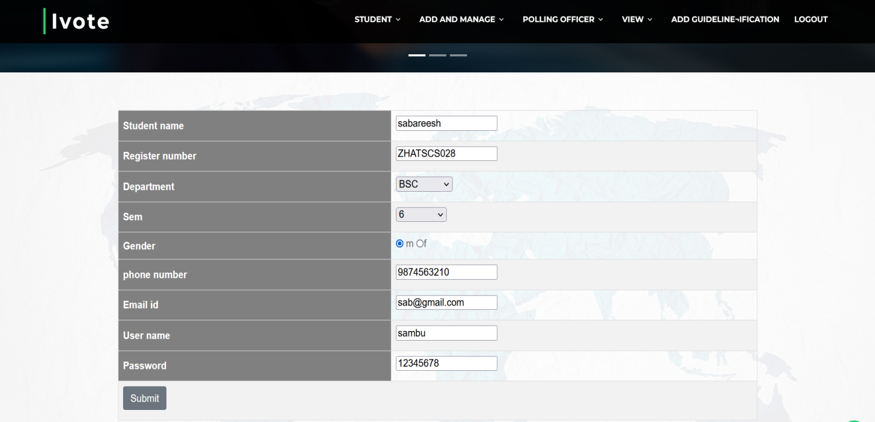

**MANAGE STUDENT**

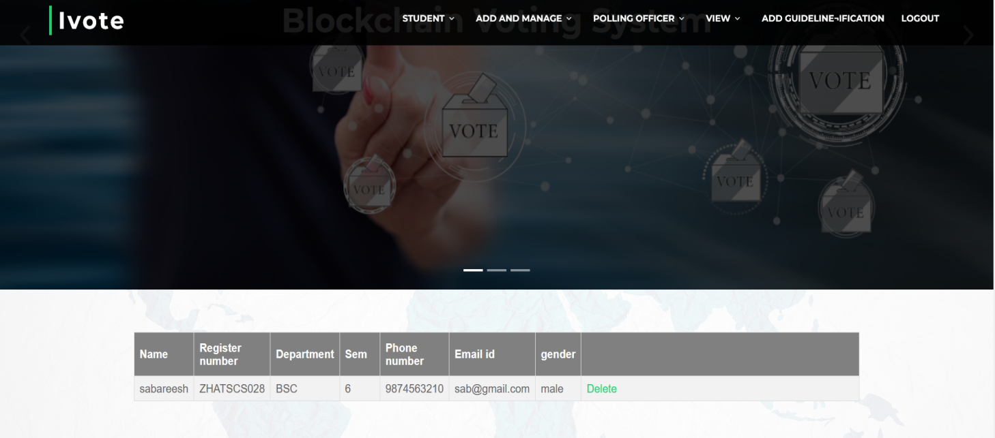

**AND & MANAGE DEPARTMENT**

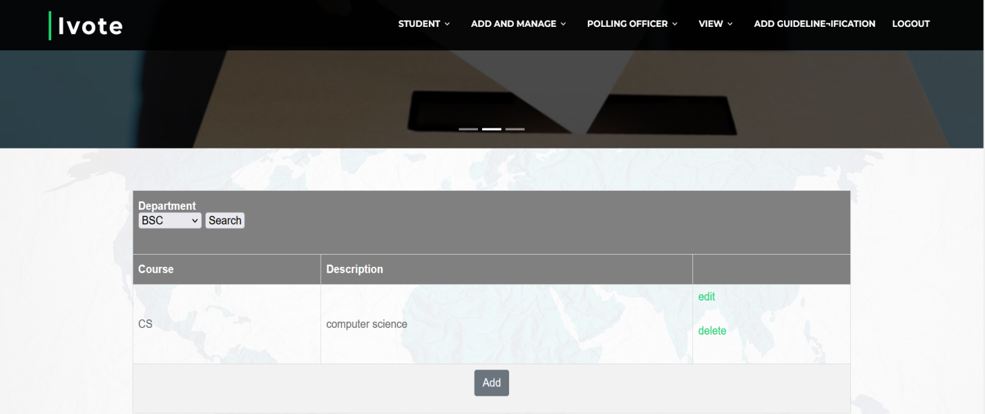

**VERIFY STUDENT**

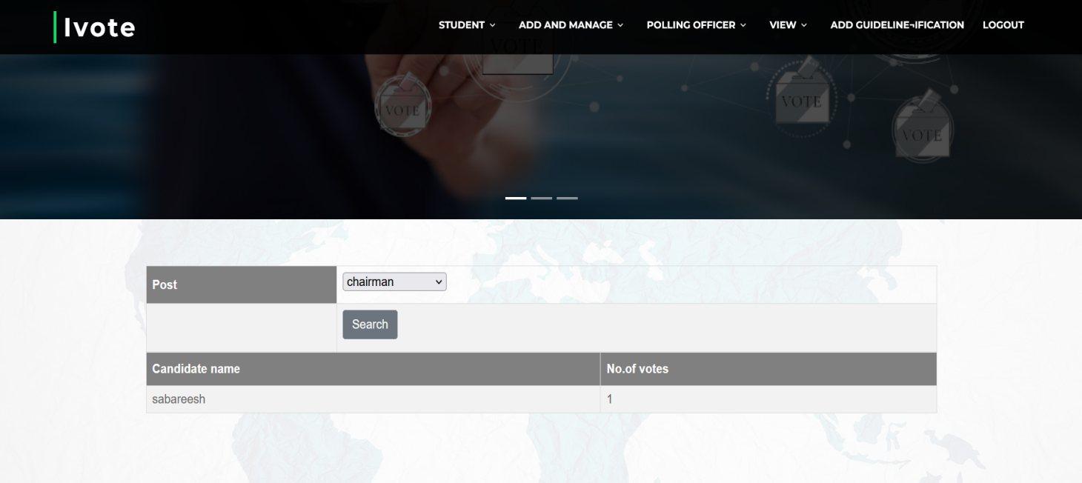

**View result**

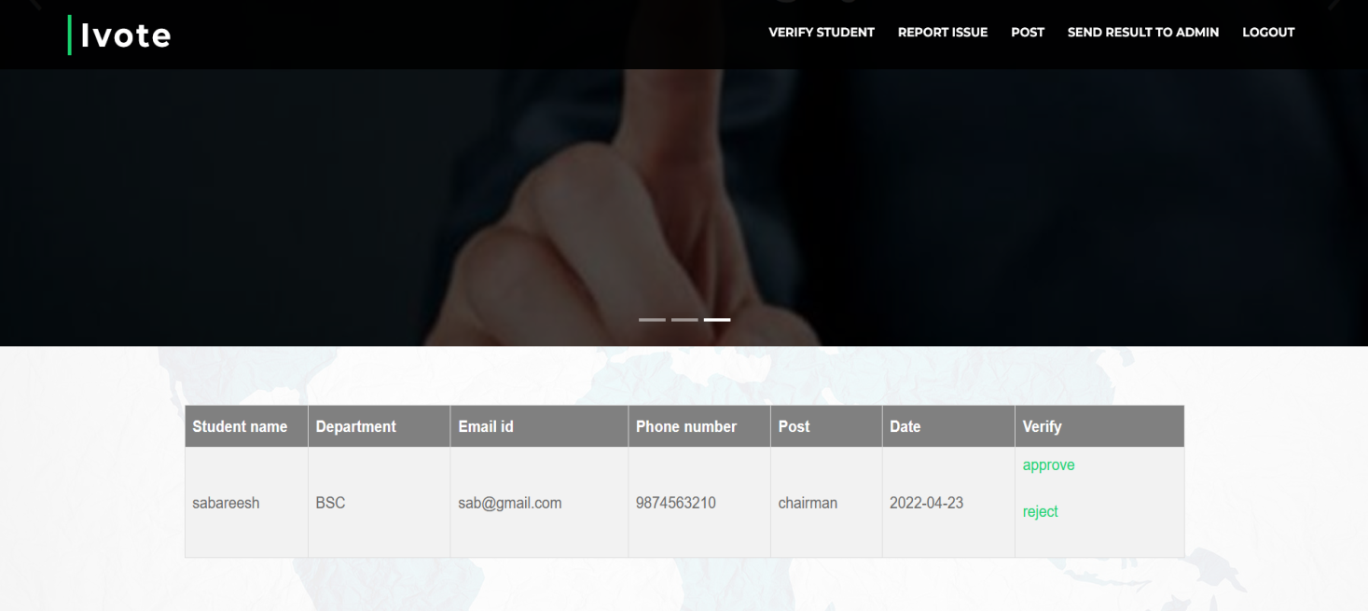

**BLOCKCHAIN**

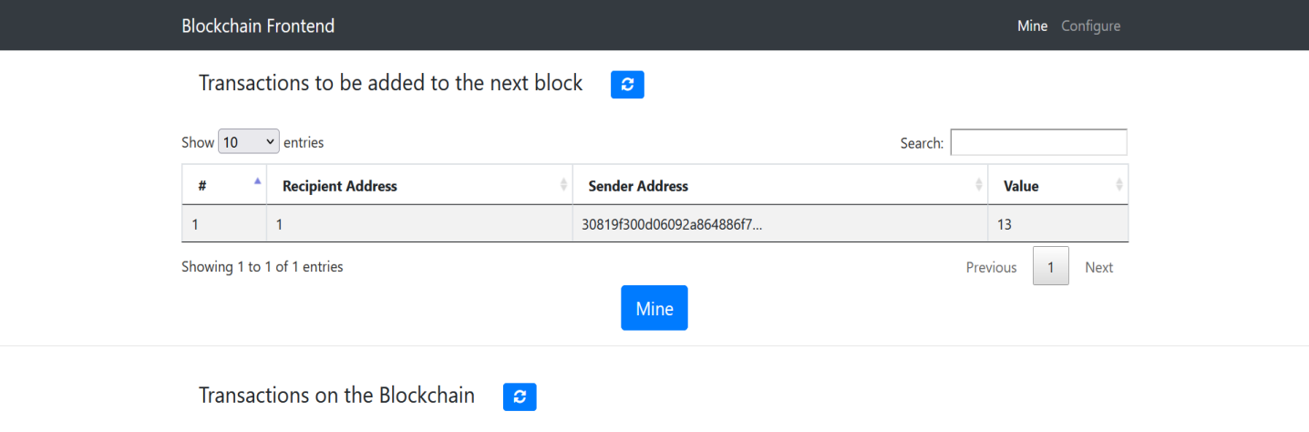

### SAMPLESOURCE

**Python**

**import** cmd  
**import** os  
  
**import** Crypto  
**import** Crypto.Random  
**import** binascii  
**from** Crypto.Hash **import** SHA  
**from** Crypto.PublicKey **import** RSA  
**from** collections **import** OrderedDict  
**from** Crypto.Signature **import** PKCS1_v1_5  
  
**from** flask **import**\*  
*# from jaseem import a***from** werkzeug.utils **import** secure_filename  
path=**r".\static\application"**app=Flask(__name__)  
**from** src.db_connection **import** *  
  
  
**class** Transaction:  
**def** __init__(self, sender_address, sender_private_key, recipient_address, value):  
self.sender_address = sender_address  
self.sender_private_key = sender_private_key  
self.recipient_address = recipient_address  
self.value = value  
  
**def** __getattr__(self, attr):  
**return** self.data[attr]  
  
**def** to_dict(self):  
**return** OrderedDict({**'sender_address'**: self.sender_address,  
**'recipient_address'**: self.recipient_address,  
**'value'**: self.value  
 })  
  
**def** sign_transaction(self):  
*"""  
 Sign transaction with private key  
"""*private_key = RSA.importKey(binascii.unhexlify(self.sender_private_key))  
 signer = PKCS1_v1_5.new(private_key)  
 h = SHA.new(str(self.to_dict()).encode(**'utf8'**))  
**return** binascii.hexlify(signer.sign(h)).decode(**'ascii'**)  
  
@app.route(**"/logincode"**,methods=[**'post'**])  
**def** lgincode():  
 uname=request.form[**'uname'**]  
 password=request.form[**'password'**]  
 q=**"select * from login where username=%s and password=%s AND user_type='student'"**val=uname,password  
 res=selectone(q,val)  
print(res)  
**if** res **is None**:  
**return** jsonify({**'task'**:**'invalid'**})  
**else**:  
**return** jsonify({**'task'**:**'success'**,**'lid'**:res[0],**'type'**:res[3]})  
  
@app.route(**"/application"**,methods=[**'GET'**,**'POST'**])  
**def** application():  
**try**:  
 studid=request.form[**'sid'**]  
print(studid)  
 post=request.form[**'pid'**]  
 applicationform=request.files[**'files'**]  
print(applicationform)  
 files=secure_filename(applicationform.filename)  
 applicationform.save(os.path.join(path,files))  
 qry=(**"insert into application values(Null,%s,curdate(),curtime(),%s,%s,'pending')"**)  
 val = (str(studid), post, files)  
 iud(qry,val)  
**return** jsonify({**'task'**: **'sucess'**})  
**except** Exception **as** e:  
**return** jsonify({**'task'**: **'already added'**})  
@app.route(**"/viewpost"**,methods=[**'GET'**,**'POST'**])  
**def** viewpost():  
 qry=(**"select * from post"**)  
 res=androidselectallnew(qry)  
print(res)  
**return** jsonify(res)  
@app.route(**"/status"**,methods=[**'GET'**,**'POST'**])  
**def** status():  
 studid = request.form[**'uid'**]  
 qry=(**"SELECT post.post_name,application.status FROM application JOIN post ON application.post_id=post.post_id WHERE application.student_id=%s"**)  
 val=studid  
 res=androidselectall(qry,val)  
**return** jsonify(res)  
  
  
@app.route(**"/post"**,methods=[**'POST'**])  
**def** post():  
 userid = request.form[**'lid'**]  
qry=(**"SELECT * FROM `post` WHERE `post_id` NOT IN(SELECT `pid` FROM `voting_tb` WHERE `uid`=%s)"**)  
 qry=(**"SELECT * FROM `post`"**)  
val=userid  
 res=androidselectallnew(qry)  
print(res)  
*# res=androidselectall(qry,val)***return** jsonify(res)  
  
@app.route(**"/candidates"**,methods=[**'POST'**])  
**def** candidates():  
print(request.form)  
 post = request.form[**'post'**]  
 qry=(**"SELECT `student`.* ,`post`.`post_id`,`post_name`,`student`.`login_id` FROM `student` JOIN `application` ON `application`.`student_id`=`student`.`login_id` JOIN `post` ON `post`.`post_id`=`application`.`post_id` WHERE `application`.`post_id`=%s AND `application`.`status`='verified'"**)  
 val=post  
 res=androidselectall(qry,val)  
print(res)  
**return** jsonify(res)  
  
@app.route(**"/result"**,methods=[**'post'**])  
**def** result():  
 pid=request.form[**'pid'**]  
print(pid,**"============================================="**)  
 qry=**"SELECT student.`student_name`,COUNT(*)`vote` FROM `student` JOIN `application` ON `application`.student_id=`student`.`login_id` JOIN `voteinfo` ON `voteinfo`.`candid`=`student`.`login_id` JOIN `result publish` ON `result publish`.`postid`=`voteinfo`.`post_id` WHERE `application`.`status`='verified' AND `result publish`.`status`='published' AND `application`.`post_id`=`voteinfo`.`post_id` and `voteinfo`.`post_id`=%s GROUP BY `voteinfo`.`candid` ORDER BY vote DESC"**val=pid  
 res=androidselectall(qry,val)  
print(res,**"======================="**)  
**return** jsonify(res)  
  
@app.route(**"/sdsa"**, methods=[**'post'**])  
**def** sdsa():  
  
 post=request.form[**'post'**]  
 userid=request.form[**'lid'**]  
 candid=request.form[**'cid'**]  
 qry=(**"SELECT * FROM `voteinfo` WHERE `post_id`=%s AND `uid`=%s"**)  
 val=post,userid  
 vv=selectone(qry,val)  
**if** vv **is None**:  
 qry=(**"insert into voteinfo values(null,%s,%s,1,%s)"**)  
 val=(post,userid,candid)  
 iud(qry, val)  
 generate1(userid)  
 qry=**"SELECT * FROM `cipher` WHERE id=%s"**val=userid  
 rse = selectone(qry,val)  
 sender_address = rse[1]  
 sender_private_key = rse[2]  
 transaction = Transaction(sender_address, sender_private_key, str(post), str(candid))  
*# response = {'transaction': transaction.to_dict()}*d = transaction.to_dict()  
 d[**'signature'**] = transaction.sign_transaction()  
print(d)  
**import** requests  
 re = requests.post(**"http://127.0.0.1:8080/transactions/new"**, data=d)  
print(re.status_code)  
  
**return** jsonify({**'task'**: **'Success'**})  
**else**:  
**return** jsonify({**'task'**: **'faild'**})  
  
  
@app.route(**'/votingg'**,methods=[**'post'**])  
**def** votingg():  
**return "okok"**@app.route(**'/generate'**, methods=[**'POST'**])  
**def** generate():  
 id=request.form[**'studid'**]  
*# random_gen = Crypto.Random.new().read  
 # private_key = RSA.generate(1024, random_gen)  
 # public_key = private_key.publickey()  
 # response = {  
 # 'private_key': binascii.hexlify(private_key.exportKey(format='DER')).decode('ascii'),  
 # 'public_key': binascii.hexlify(public_key.exportKey(format='DER')).decode('ascii'),  
 #  
 # }*qry=(**"SELECT public_key,private_key FROM cipher where id=%s"**)  
 val=id  
 a = selectone(qry,val)  
**if** a **is None**:  
 qry=(**"insert into cipher values(%s,%s,%s"**)  
*# val=id,str(response['public_key']),str( response['private_key'])*iud=(qry,val)  
  
**else**:  
 qry=(**"update cipher set public_key=%s,private_key=%s where id=%s"**)  
*# val= str(response['public_key']),str(response['private_key']),id*iud=(qry,val)  
**return** jsonify({**'task'**: **"success"**})

**def** generate1(id):  
  
 random_gen = Crypto.Random.new().read  
 private_key = RSA.generate(1024, random_gen)  
 public_key = private_key.publickey()  
 response = {  
**'private_key'**: binascii.hexlify(private_key.exportKey(format=**'DER'**)).decode(**'ascii'**),  
**'public_key'**: binascii.hexlify(public_key.exportKey(format=**'DER'**)).decode(**'ascii'**),  
  
 }  
 qry=(**"SELECT public_key,private_key FROM cipher where id=%s"**)  
 val=(id,)  
 a = selectone(qry,val)  
**if** a **is None**:  
 qry=**"insert into cipher values(%s,%s,%s)"**val=(id,str(response[**'public_key'**]),str(  
 response[**'private_key'**]))  
 iud(qry,val)  
@app.route(**'/sendcomp'**,methods=[**'post'**])  
**def** sendcomp():  
 pid = request.form[**'lid'**]  
 comp=request.form[**'comp'**]  
 qry=**"insert into complaint values(NULL,%s,curdate(),%s,'pending')"**val=(pid,comp)  
 iud(qry,val)  
**return** jsonify({**'task'**:**'successful'**})  
@app.route(**'/viewreply'**,methods=[**'post'**])  
**def** viewreply():  
 pid = request.form[**'lid'**]  
 qry=**"select*from complaint where u_id=%s"**res=androidselectall(qry,pid)  
**return** jsonify(res)  
@app.route(**'/viewguide'**,methods=[**'post'**])  
**def** viewguide():  
 qry=**"select*from guideline"**res=androidselectallnew(qry)  
**return** jsonify(res)  
  
  
  
  
  
  
**if** __name__ == **'__main__'**:

**Android**

package com.example.voting;

import android.app.Activity;

import android.content.Intent;

import android.content.SharedPreferences;

import android.os.Bundle;

import android.preference.PreferenceManager;

import android.util.Log;

import android.view.View;

import android.widget.Button;

import android.widget.EditText;

import android.widget.Toast;

import com.android.volley.Request;

import com.android.volley.RequestQueue;

import com.android.volley.Response;

import com.android.volley.VolleyError;

import com.android.volley.toolbox.StringRequest;

import com.android.volley.toolbox.Volley;

import org.json.JSONObject;

import java.util.HashMap;

import java.util.Map;

public class login extends Activity {

EditText ed,ed1;

Button b2;

String username,password,ip,url;

SharedPreferences sh;

@Override

protected void onCreate(Bundle savedInstanceState) {

super.onCreate(savedInstanceState);

setContentView(R.layout.activity_login);

ed = findViewById(R.id.uname);

ed1 = findViewById(R.id.editTextTextPassword);

b2 = findViewById(R.id.button5

);

sh= PreferenceManager.getDefaultSharedPreferences(getApplicationContext());

ip=sh.getString("ip","");

url="http://"+sh.getString("ip","")+":5000/logincode";

b2.setOnClickListener(new View.OnClickListener() {

@Override

public void onClick(View view) {

username=ed.getText().toString();

password=ed1.getText().toString();

if(username.equalsIgnoreCase(""))

{

ed.setError("enter yor username");

}

else if (password.equalsIgnoreCase(""))

{

ed1.setError("enter your password");

}

else {

RequestQueue queue = Volley.newRequestQueue(login.this);

// Request a string response from the provided URL.

StringRequest stringRequest = new StringRequest(Request.Method.POST, url, new Response.Listener<String>() {

@Override

public void onResponse(String response) {

// Display the response string.

try {

JSONObject jo = new JSONObject(response);

String status = jo.getString("task");

Toast.makeText(login.this, status, Toast.LENGTH_SHORT).show();

if (status.equalsIgnoreCase("success")) {

String lid = jo.getString("lid");

SharedPreferences.Editor edt = sh.edit();

edt.putString("lid", lid);

edt.commit();

Toast.makeText(login.this, status, Toast.LENGTH_SHORT).show();

Intent

in = new Intent(getApplicationContext(), STUDENTHOME.class);

startActivity(in);

//

} else if (status.equals("invalid")) {

Toast.makeText(login.this, "Invalid username or password", Toast.LENGTH_SHORT).show();

}

} catch (Exception e) {

Log.d("=========", e.toString());

Toast.makeText(login.this, "" + e, Toast.LENGTH_SHORT).show();

}

}

}, new Response.ErrorListener() {

@Override

public void onErrorResponse(VolleyError error) {

Toast.makeText(login.this, error.getMessage(), Toast.LENGTH_SHORT).show();

}

}) {

@Override

protected Map<String, String> getParams() {

Map<String, String> params = new HashMap<>();

params.put("uname", username);

params.put("password", password);

return params;

}

};

// Add the request to the RequestQueue.

queue.add(stringRequest);

}

}

});

}

public void onBackPressed() {

Intent startMain = new Intent(Intent.ACTION_MAIN);

startMain.addCategory(Intent.CATEGORY_HOME);

startMain.setFlags(Intent.FLAG_ACTIVITY_NEW_TASK);

startActivity(startMain);

}

}